**IMDB - BI Movies**

* **Worldwide Lifetime Gross based on Running Minutes**

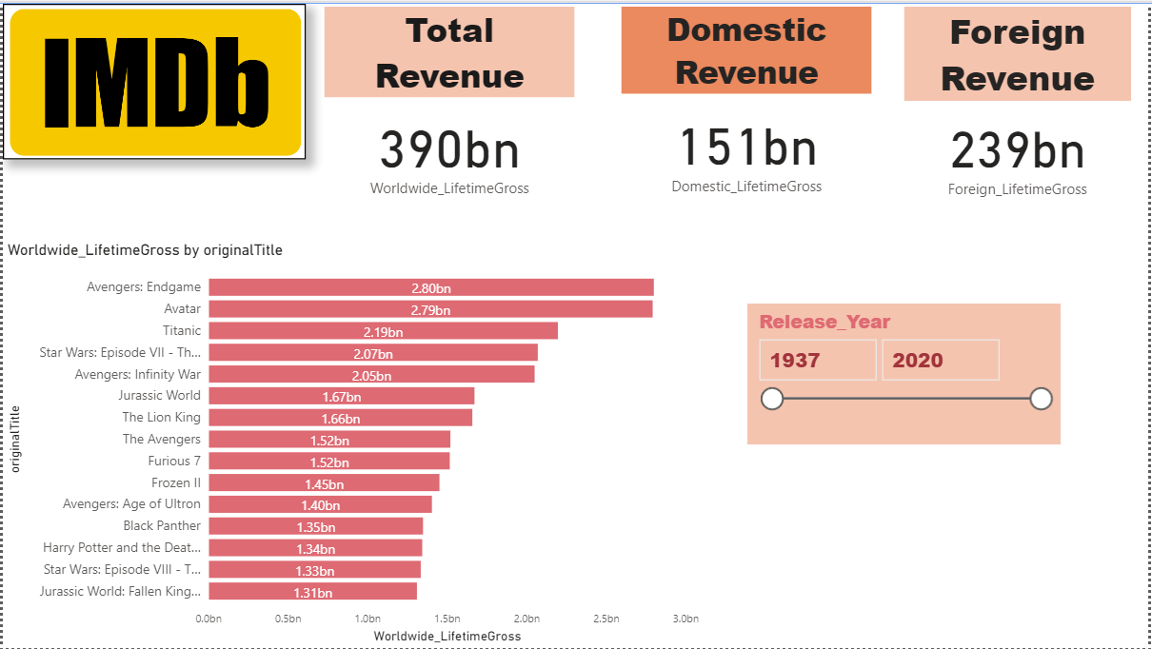

* **Top 100 Movies by Genre, Rating & Running Time**

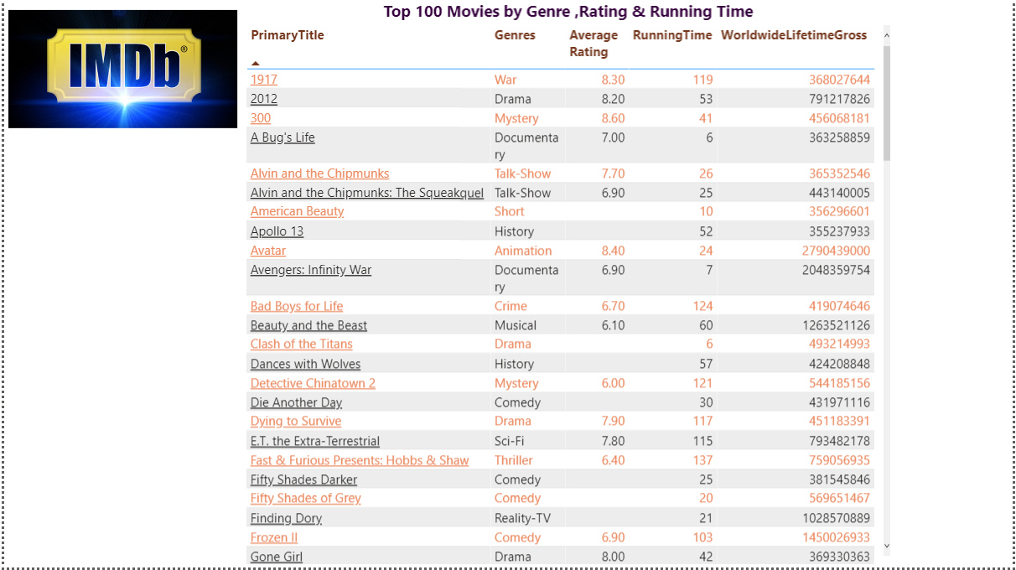

* **Top 25 Movies Based on Domestic and Foreign Revenue**

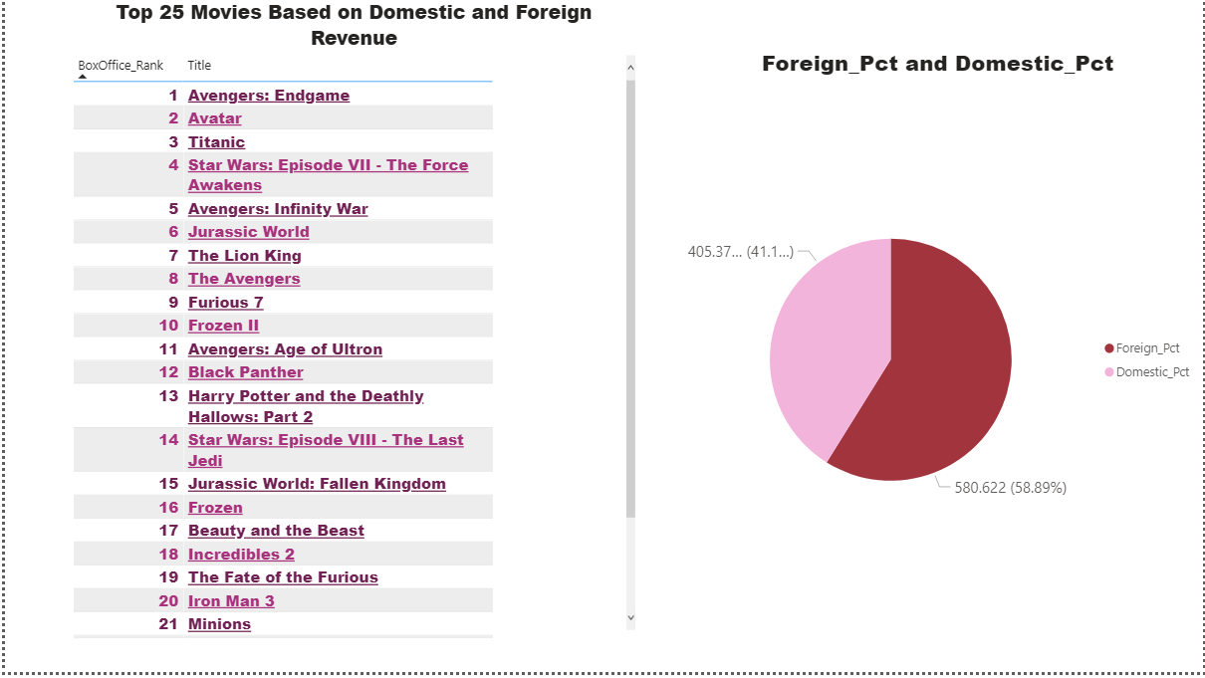

* **Top 25 Movies based on Number of Votes and Title Type**

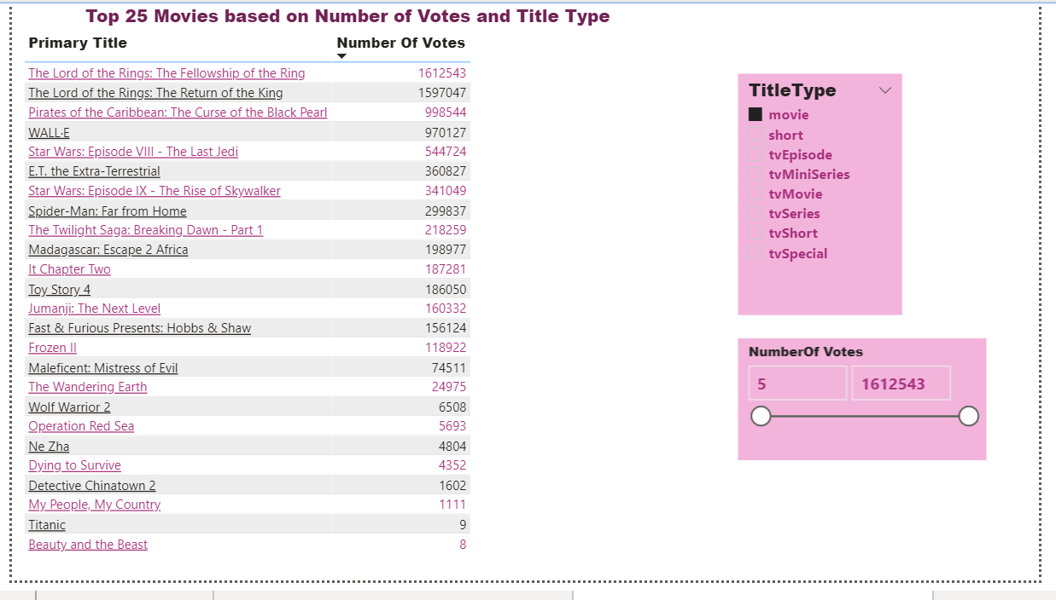

* **Average Rating by Genre and Years**

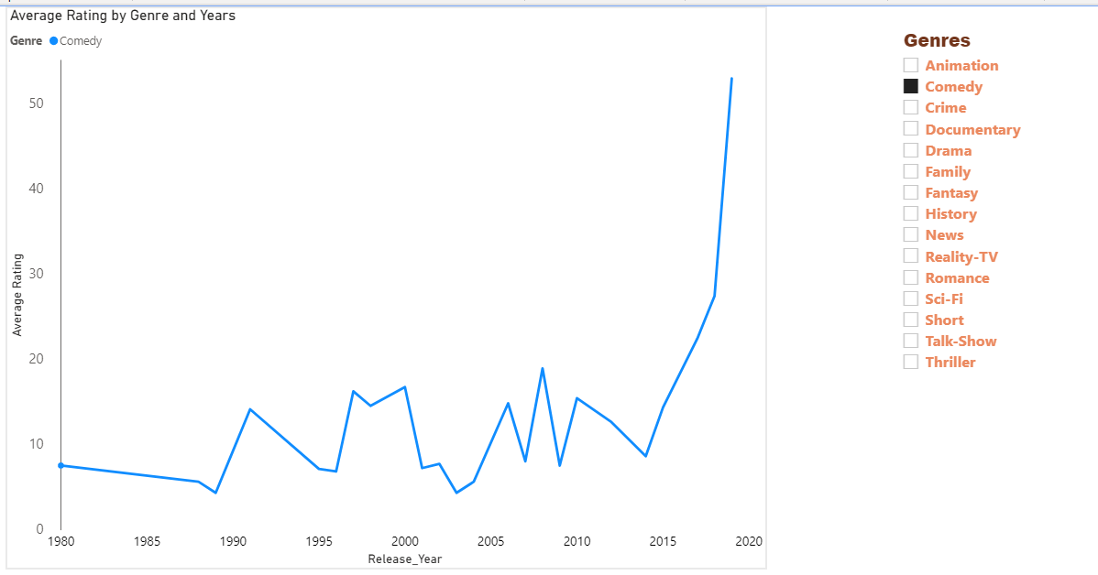

* **Top 25 Title based on IMDb rating and Title Type**

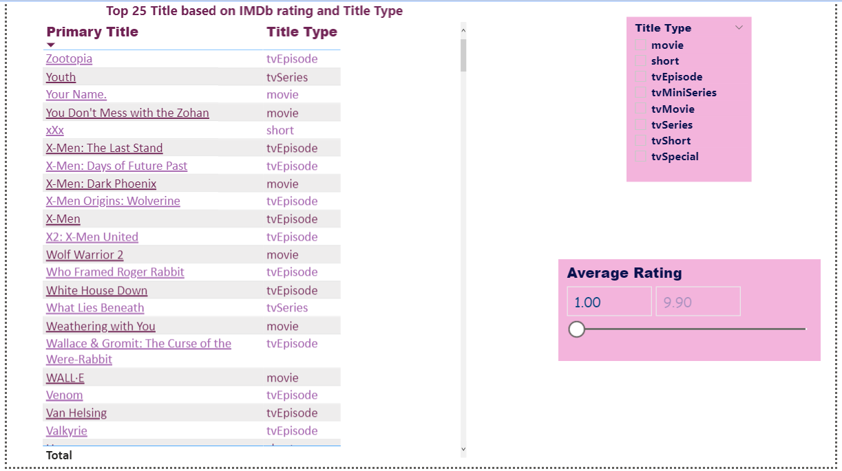

* **People Involved with Movies**

